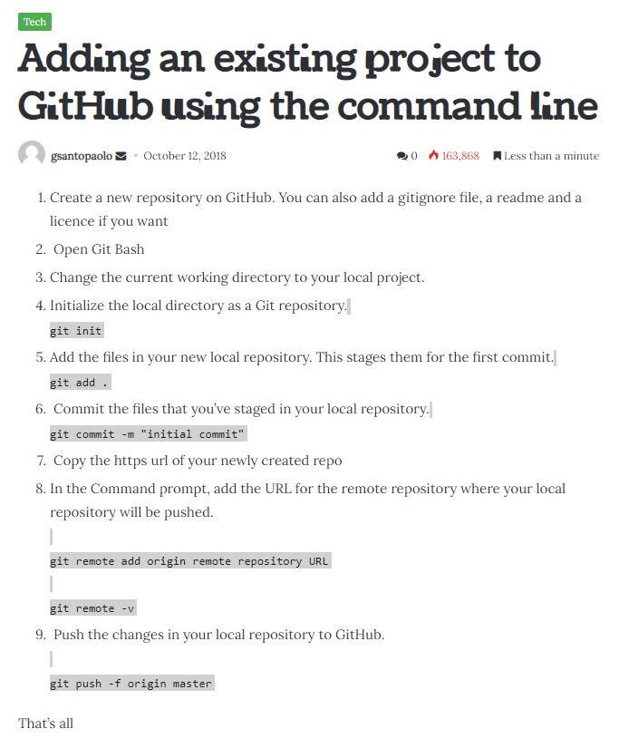

* **Git log**
* **Git status**
* **Again start from git add .**